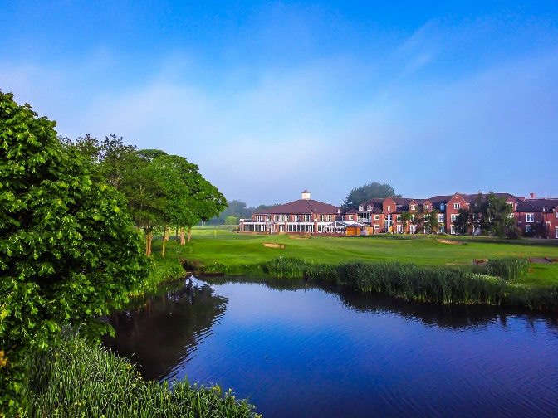

The Concrete Repair Association (CRA) is delighted to be hosting the CRA General Meeting and Social Day 2023!

Join us on Thursday the 6th July at the stunning Formby Hall Golf Resort and Spa for our Annual General Meeting followed by an action packed day of activities including golf or clay pigeon shooting. Our evening will begin with a sit down dinner, followed by a comedy set and prize giving from the day’s events.

Places are limited so book early by completing and returning this form to caroline.peck@agmhouse.com

Schedule:
11:00 Meeting
12:30 Lunch
13:30 First Golf Tee/ coach departs to shooting range
19:00 Drinks reception
19:30 Dinner
21:00 Guest Speaker

Dress Code: Casual, Golf attire, Shooting attire (Daytime only)
Smart Casual (Evening only)

Contact Information:

Contact Name:
Company Name:
Email Address:
Phone Number:

Activities:

 | Cost | Quantity | Total Cost
Golf (per person) | £50 + VAT
Shooting (per person) | £59.99 + VAT
Dinner (per person) | £70.00

Attendance:

I will be attending the AGM | Dietary Requirements | I require accommodation*

A limited number of rooms have been reserved at Formby Hall for CRA members. If you require accommodation please complete the accommodation section above.

Please note – the CRA are not responsible for accommodation costs. Individuals accommodation is to be settled upon departure.

Formby Hall Golf Resort & Spa, Formby
Southport Old Road, Formby, Southport, L37 0AB
Tel: 01704 875 699
Payment details:
- I wish to pay by credit card (please contact the office to make payment)
- I would like to be invoiced, purchase number (if required) ……………………………………………………………

COMPANY: | MAIN CONTACT:
EMAIL ADDRESS:

To make a payment/ if you have any questions, please contact the CRA office on 01420 471615. Please note that your place/s are not guaranteed until this booking form has been submitted and any outstanding payments received.

